Distributed set up

Distribute set up in Jenkins

=========================================

> when we have many scripts to be executed using many users and using many servers

> when you have requirement to do performance testing a particular region of user

> when testing has to be done on different platform

> in distributed set up we will have 1 main jmeter server and jmeter scripts/samplers

> We will have host servers that will act as workers where script will be executed remotely

Distributed Set up:

========================

master node:

- java version >= 8

- environment variables for java have to be set

- Jmeter 5.6.2

Remote machine:

- java version >= 8

- environment variables for java have to be set

- Jmeter 5.6.2

Distributed set up we will use same machine as master and as slave

Step 1: Ip address of current laptop:

> open command prompt > execute command ipconfig

IPv4 Address. . . . . . . . . . . : 192.168.1.7

Step 2:

> go Apache jmeter folder/bin

> open the jmeter properties file

> make changed to remote_hosts section

> Add the remote_hosts = 192.168.1.7

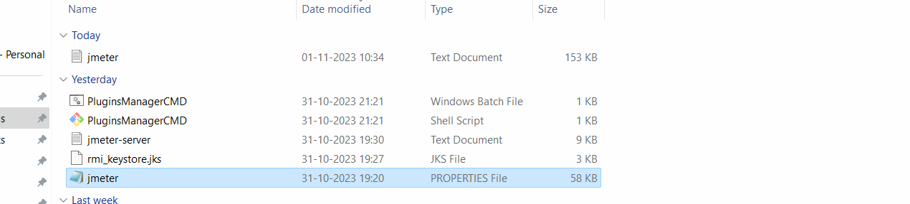

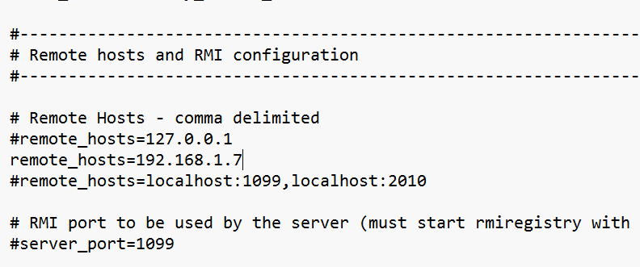

In the same file search for server.rmi.ssl.disable

Remove the #

server.rmi.ssl.disable = true

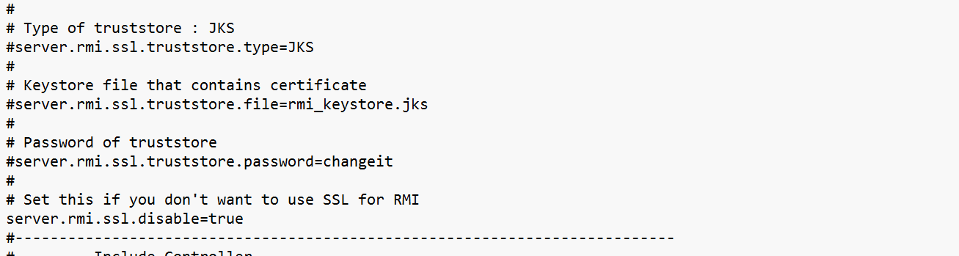

Stop and restart your jmeter

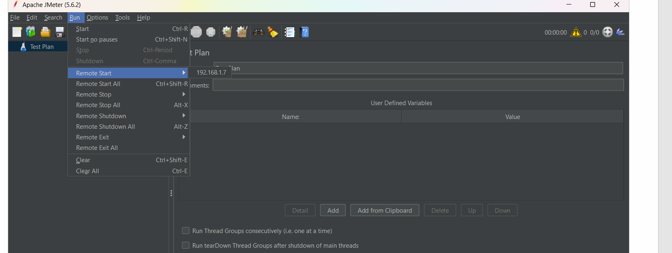

Again go to Apache folder/bin folder and search for a file with name:

create-rmi-keystore -> windows batch file

This file is executable. Double click on it and it will open a command prompt and enter as show below details and press enter

A file with name rmi_keystore.jks will get generated

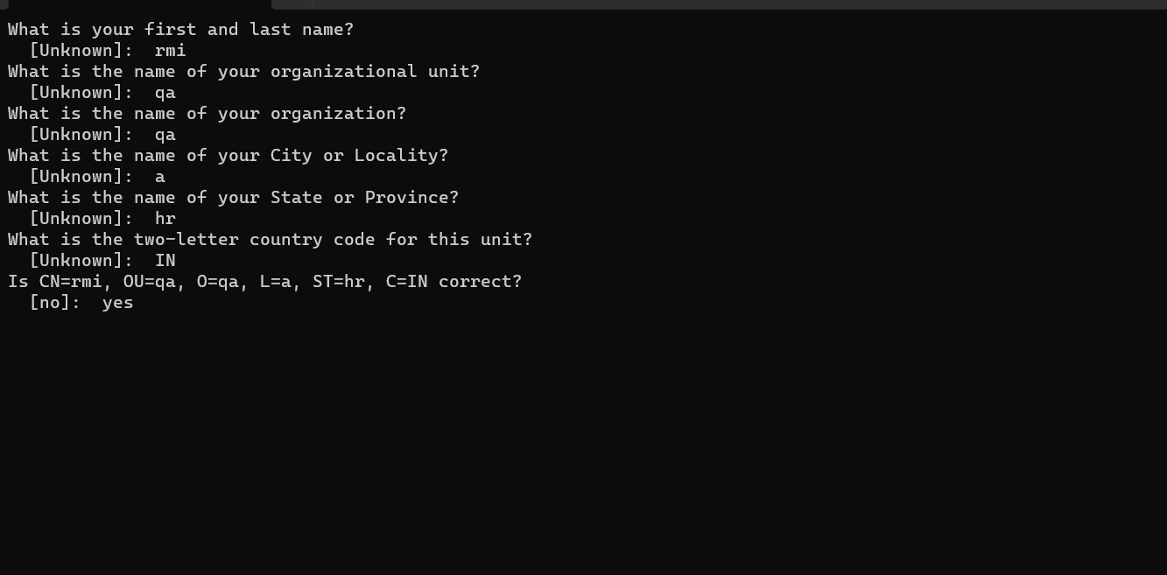

A file with name rmi_keystore.jks will get generated

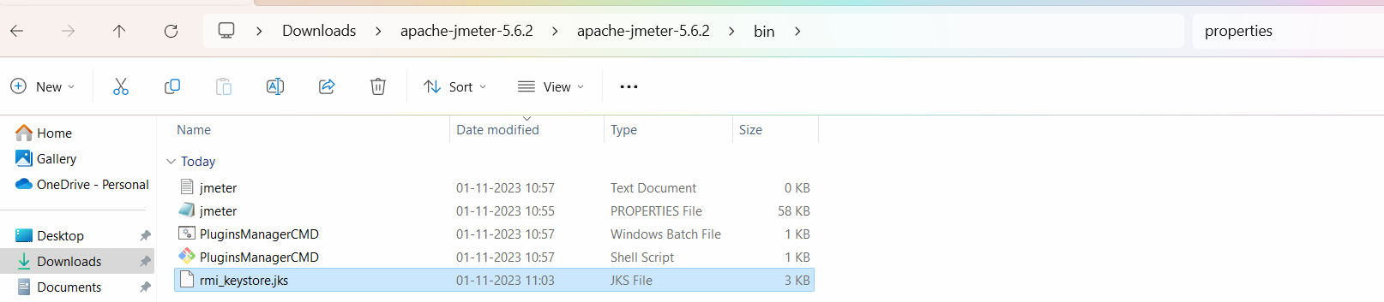

In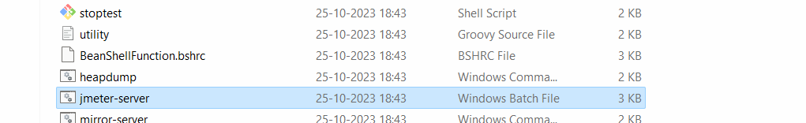 the bin folder itself search for jmeter-server -> windows batch file

Double click on it, it will open command prompt and make connect between master and slave

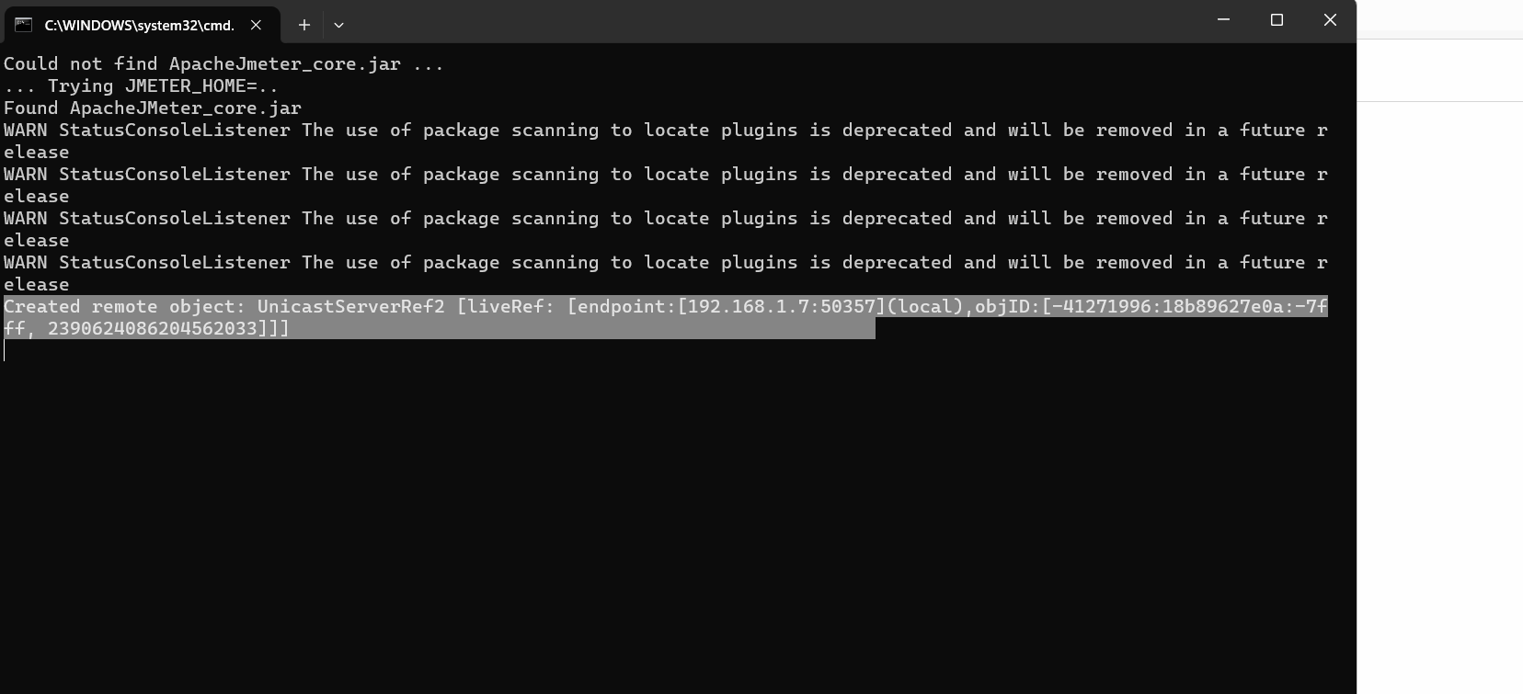

Keep the command prompt running/open.

Stop and restart jmeter

Create a test on jmeter and go to Menu option 🡪 run 🡪 Click on remote start

